
MUUGLines
The Manitoba UNIX User Group Newsletter
Volume 38 No. 10, June 2026 Editor: Bradford C. Vokey
Next Meeting: June 2nd, 2026 7:30pm
As usual MUUG is meeting on the first Tuesday of the month.
Come join us for the last formal MUUG meeting until September.
FYI, we will also have an informal summer BBQ on July 14th – see the article on page 5.

Main Presentation: Local certificates and CA’s
There are many tools and services to get you up and running with a web server certificate issued by a trusted CA (Certificate Authority). The internet is filled with many good tutorials on how to do just that. So why yet another? The vast majority of those don’t cover the case where you have an internal website (not accessible by the internet, and maybe without internet access itself) and you still need to have a proper (not self-issued) certificate so your internal web clients (browsers) know this is a trusted website.
Kevin McGregor will describe the concepts and process needed to make this happen. And to speed it up, no demos!

RTFM: /bin Diving
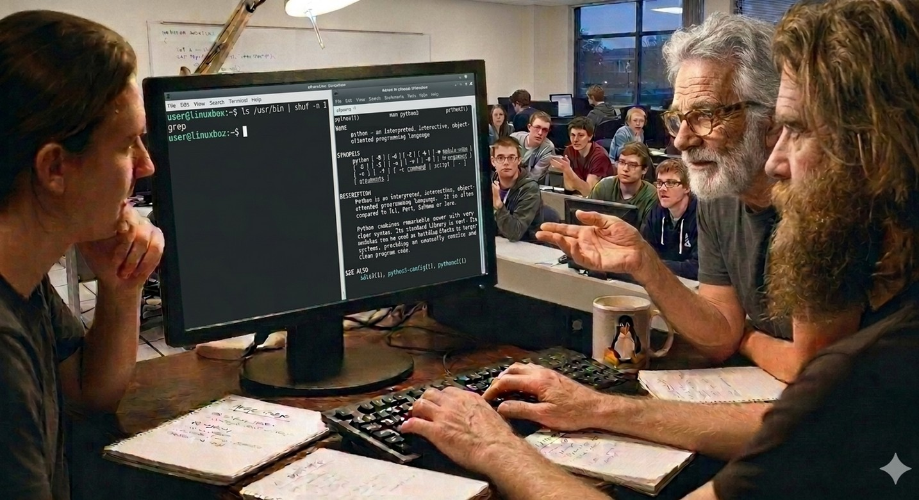
Time permitting, Wyatt Zacharias will then try to figure out what a random /bin command does — live in front of the group.
Fun group discussions and insights usually ensue. Come for the fun of it, and stay for the group participation and shared learning opportunity!

The latest meeting details are always at:

https://muug.ca/meetings/
Where to Find the Meeting:

Winnipeg Senior Citizens Radio Club
598 St. Mary’s Rd. Winnipeg, MB.


MUUG is continuing to meet at our new location. The Winnipeg Senior Citizens Radio Club (WSC).
WSC is located at 598 St. Mary’s Road, 2nd Floor, a block South from the St. Mary’s / St. Anne’s fork, on the West side beside the Miller’s Meats. It’s in the old fire hall, so you really can’t miss it! Look for the red doors.
The meeting space is on the 2nd floor and there is no elevator, so attendees will have to be able to climb 1 flight of beautiful character style stairs. Apologies to anyone requiring accessibility. It is also possible to attend via online videoconferencing:

https://muug.ca/meet

Please Remove Your Footwear
To keep the carpets clean and dry please remove your outdoor footwear at the top of the stairs.
Please feel free to bring your own comfortable indoor slippers.

Entry Log Book
To support WSC operations, we ask all guests to sign the log book provided by WSC as you enter the meeting space. They have been very generous in providing MUUG space to hold their meetings, and respectfully appreciate the log book signing.
To attend the meeting via the internet:
Go to muug.ca/meet anytime after 7:00 pm on June 2nd. There is no need to create an account in Big Blue Button, nor login. Just enter a name as your screen name and click on the join button.
MUUG Yearly Membership
If your MUUG membership has lapsed, or if you would like to join us, please help support us by renewing or joining today! A simple $20 membership payment can be made via e-transfer, credit card, or PayPal here:

https://muug.ca/about.php#payment
MUUG Door Prizes

Every month MUUG gives away a couple of tech themed e-books, a current physical copy of Linux Magazine and some months we even have physical paper books and magazines to give away!
Everyone is encouraged to enter the door prize draw, both in-person and virtual attendees. You don’t have to be a member to enter, but members have exclusive access to the first draw. Members also get the privilege of not having to be present (physically or virtually) for the draw in order to claim their prize.
Linux Patch and Reboot Required!
The Linux kernel has been hit hard in May with many Linux Privilege Escalation (LPE) vulnerabilities (Copy Fail, Dirty Frag, Fragnesia, PinTheft & ssh-keysign-pwn). Most require local user access but it probably won’t take long before remote exploits start happening as well.
So everyone please keep your Linux distribution up to date – and as this is a kernel vulnerability – reboot!
Linux is Getting a Kill Switch
When critical security flaws are disclosed, servers are often left vulnerable during the time it takes to build, distribute, and reboot into a patched kernel. Rather than patching the underlying code, the kill switch intercepts calls to a specific buggy function and forces it to return a predefined value and exit without running.
So Linux kernel maintainers are considering an emergency runtime “kill switch” patch for the operating system. Pitched by NVIDIA engineer Sasha Levin, the tool allows system administrators to instantly disable specific, vulnerable kernel functions until official patches are released, preventing attackers from taking advantage of unpatched zero-day exploits.
For most users, the cost of “this socket family stops working for the day” is much smaller than the cost of running a known vulnerable kernel until the fix lands.
While the feature acts as a valuable “first-aid kit” for commercial users and enterprise environments, it has caused a fierce debate within the cybersecurity community. Modifying kernel functions on the fly can cause software to run into undefined behaviour, potentially leading to accidental denial of service or crashes if critical operations are disabled.
As of now, the patch is still under active review by the Linux kernel community and has not yet been merged into the mainstream kernel.

https://www.theregister.com/oses/2026/05/11/linux-kernel-maintainers-pitch-emergency-killswitch-after-copyfail-and-dirty-frag-chaos/5237801

https://itsfoss.com/news/linux-killswitch-proposal/
YSAP (you suck at programming)
Interesting Unix/bash videos from the mind of Dave Eddy.
Check out his unique web site (written in bash) or YouTube channel for videos that cover cool Unix/Bash facts or gotchas, offering insights that are either useful or, at the very least, interesting.

https://ysap.sh
https://www.youtube.com/@yousuckatprogramming
GNOME Commander 2.0 Released with Rust and GTK4 Rewrite
GNOME Commander 2.0 has been released as a major update to the classic two-pane graphical file manager for Linux desktops, bringing a completed GTK4 migration, extensive Rust porting work, and a new embedded terminal.
According to the project, the app is now almost completely migrated from C++ to Rust, and the move to GTK4 is complete. The update also adds an embedded terminal, allowing users to view command output within the file manager without switching to a separate terminal window.
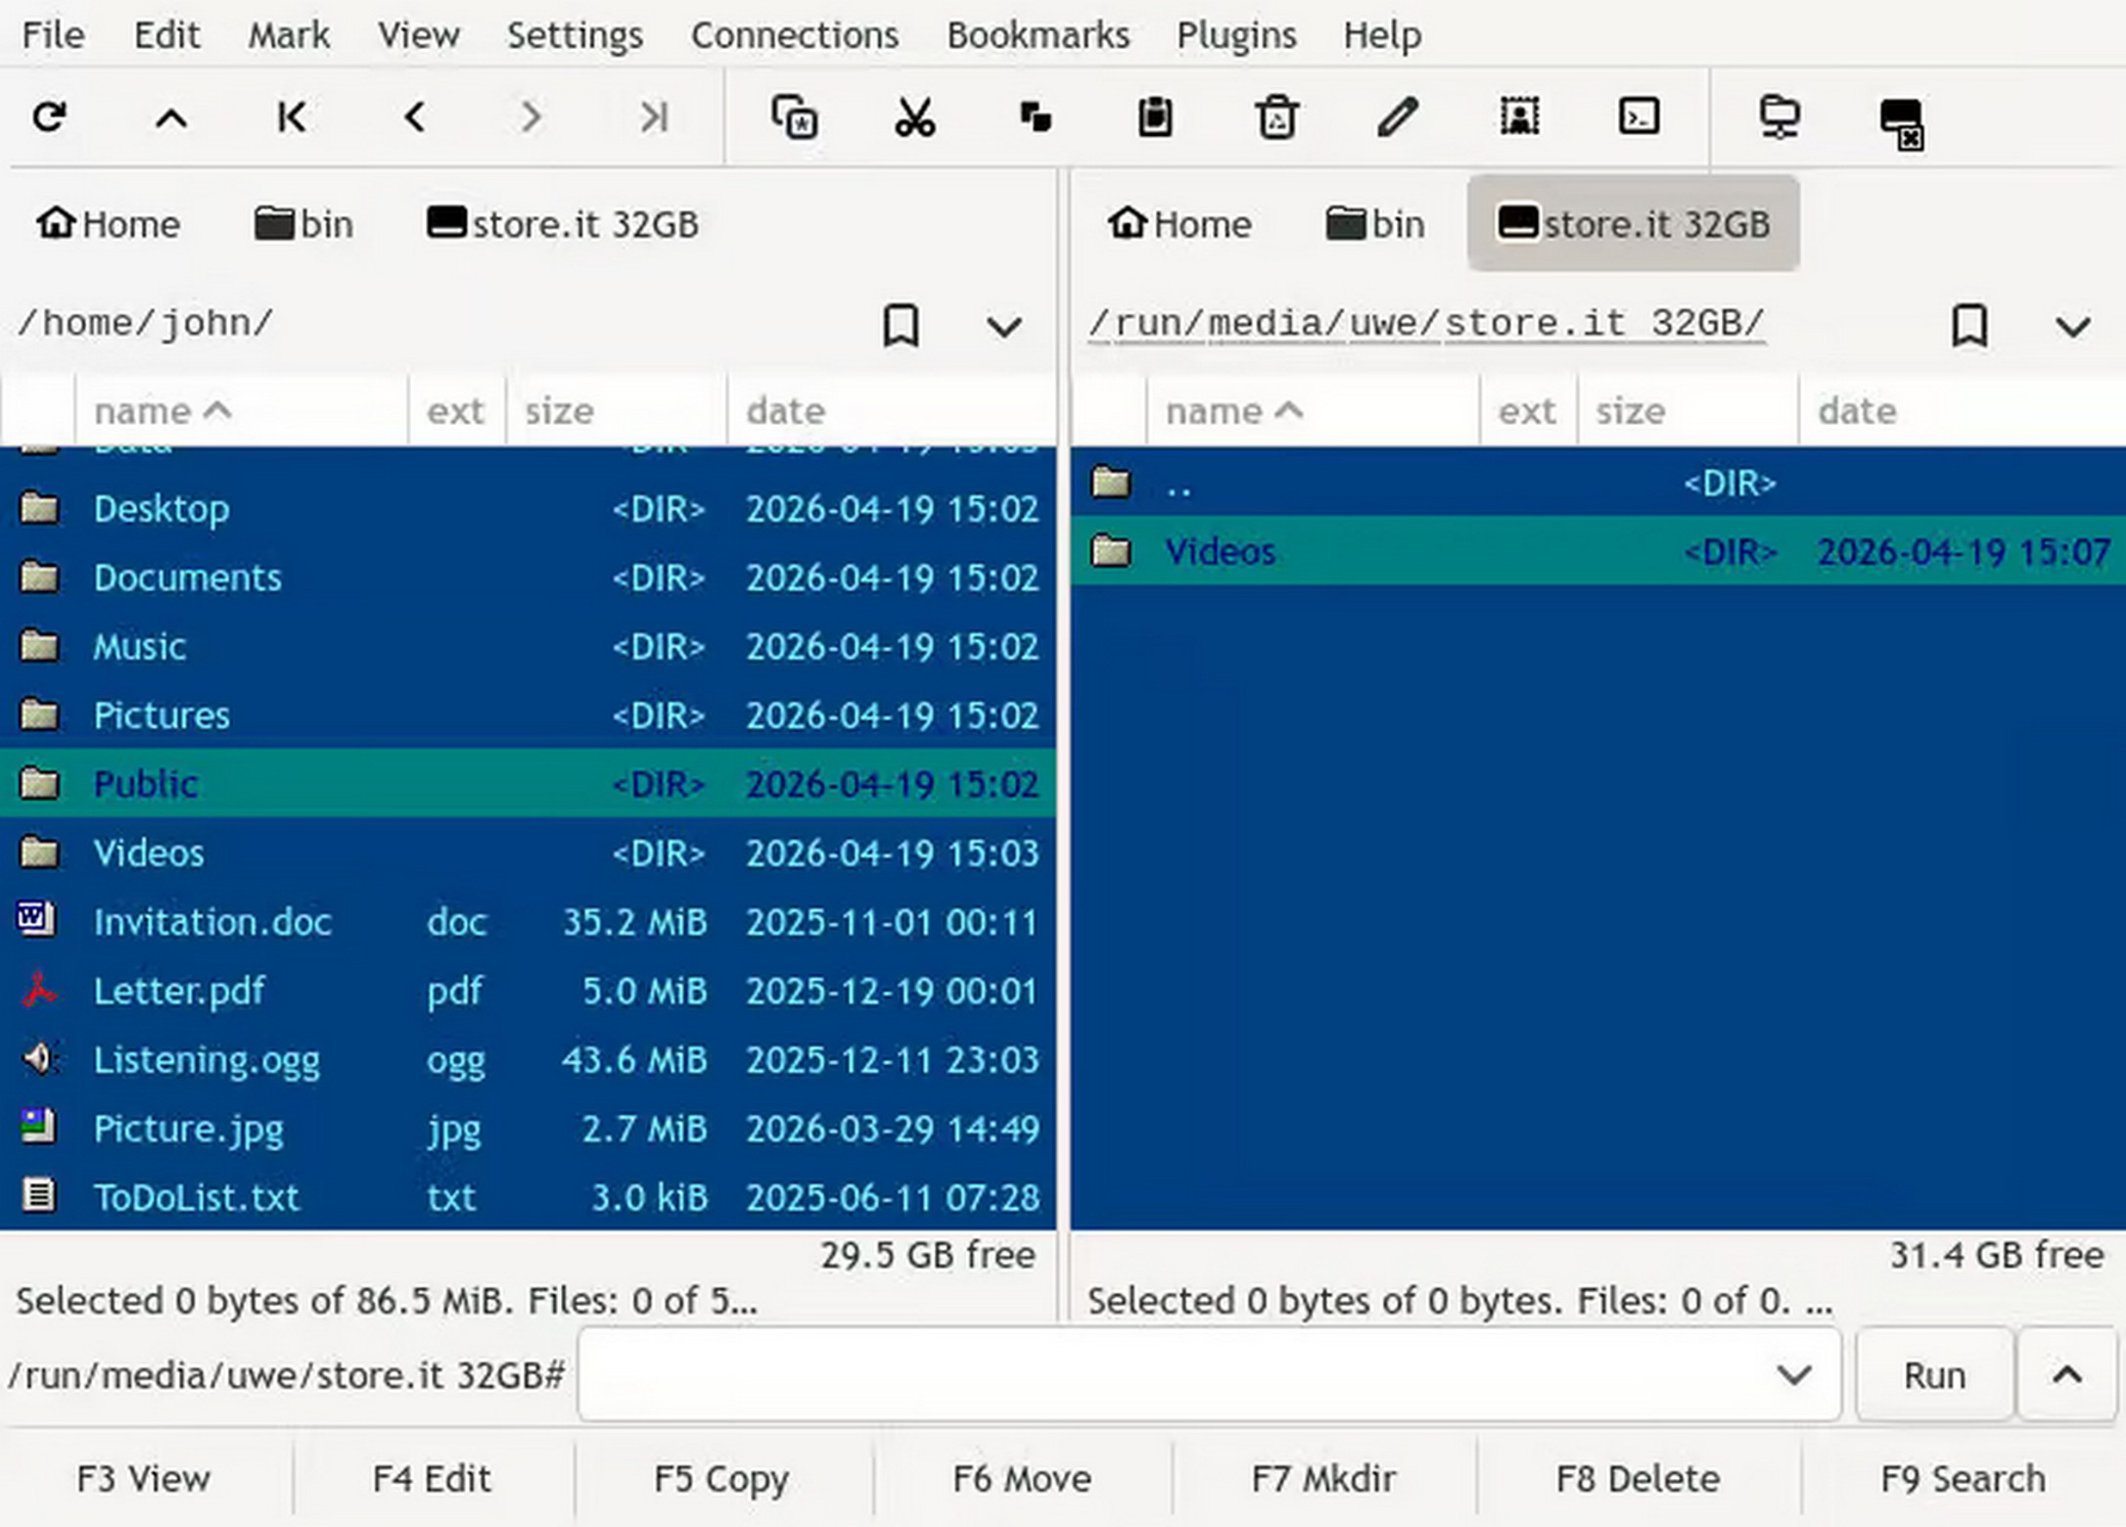
Version 2.0 brings a redesigned quick search, improvements to the search dialog, updates to the internal viewer, accessibility improvements, and Wayland fixes.

https://linuxiac.com/gnome-commander-2-0-released-with-rust-and-gtk4-rewrite/
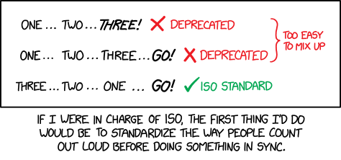
Argh, what about 3... 2... 1... 0... Go?

https://xkcd.com/3232/
How Jennifer Aniston and Friends Cost Discourse 377GB and Broke ext4 Hardlinks
In a recent blog post, Jake Goldsborough from Discourse describes his adventures trying to fix a backup problem, which just caused more problems, which we can all relate to.
It started with backup issues. Sites with hundreds of gigabytes of uploads were running out of disk space during backup generation. One site had 600+ GB of uploads and the backup process kept dying.
While looking into reliable large backups, they discovered something wild in one of those sites: the actual unique content was a fraction of the reported size. They were storing the same files over and over again, each with a different filename. The duplication was absurd.
So they shipped an optimization. Detect duplicate files by their content hash, use hardlinks instead of downloading each copy. They wrote some new tests, they all passed, it got approved and merged. But unfortunately, a fix like this is kind of hard to actually fully test.
Then someone ran it on a real production backup and hit a filesystem limit they didn’t know existed. Turns out ext4 has a limit: roughly 65,000 hardlinks per inode. So he investigated what file was breaking ext4.

A 1.6 MB GIF, duplicated 246,173 times. 377 GB of backup bloat from a single image.
And then he saw what it was.
A reaction GIF. Used constantly in posts, PMs, everywhere. Each use in a different security context creates a new copy. 246,173 copies of Rachel from Friends doing a happy dance.
And now we all know that Jennifer Aniston can stress-test infrastructure.
https://blog.discourse.org/2026/04/how-jennifer-aniston-and-friends-cost-us-377gb-and-broke-ext4-hardlinks/
RevPDF 4.0 released

At the April MUUG roundtable session, Kevin McGregor asked if anyone had a good PDF OCR solution. Turns out RevPDF has recently just updated their PDF editor to now include built-in OCR! And just like he wanted – it embeds the text results directly back into the original scanned image.
RevPDF is a lightweight, fully offline Linux native PDF editor that requires roughly only 22MB of space and doesn’t upload your sensitive documents to the cloud. It features a fast C++ engine, built-in OCR, form building, and redacting tools for secure desktop use.
The OCR is powered by Tesseract, the industry-standard, fully open-source on-device OCR engine which was even recommended at our MUUG meeting that night. But now, when you run the OCR on a scanned or image-based PDF inside RevPDF, it generates an invisible text layer directly over the original image. The resulting document looks exactly like the scanned image, but becomes fully selectable, highlightable, copyable, and searchable!
Kevin, please give it a try and then give MUUG a nice demo telling us how well it works!

https://revpdf.com/
$1,000 worth of Free Credit Card Processing!

If you ever have a need to collect credit card payments be sure to sign up with Square
(the credit card processor that MUUG uses) and both you and MUUG will receive $1,000 in free processing for the next 6 months (180 days).
You must use the following referral link to receive the credit:
https://squareup.com/i/MANITOBAU1
Voyager 1 is still transmitting from beyond the heliosphere on 22 watts!
Apropos news for our generous meeting host: The Winnipeg Senior Citizens Radio Club
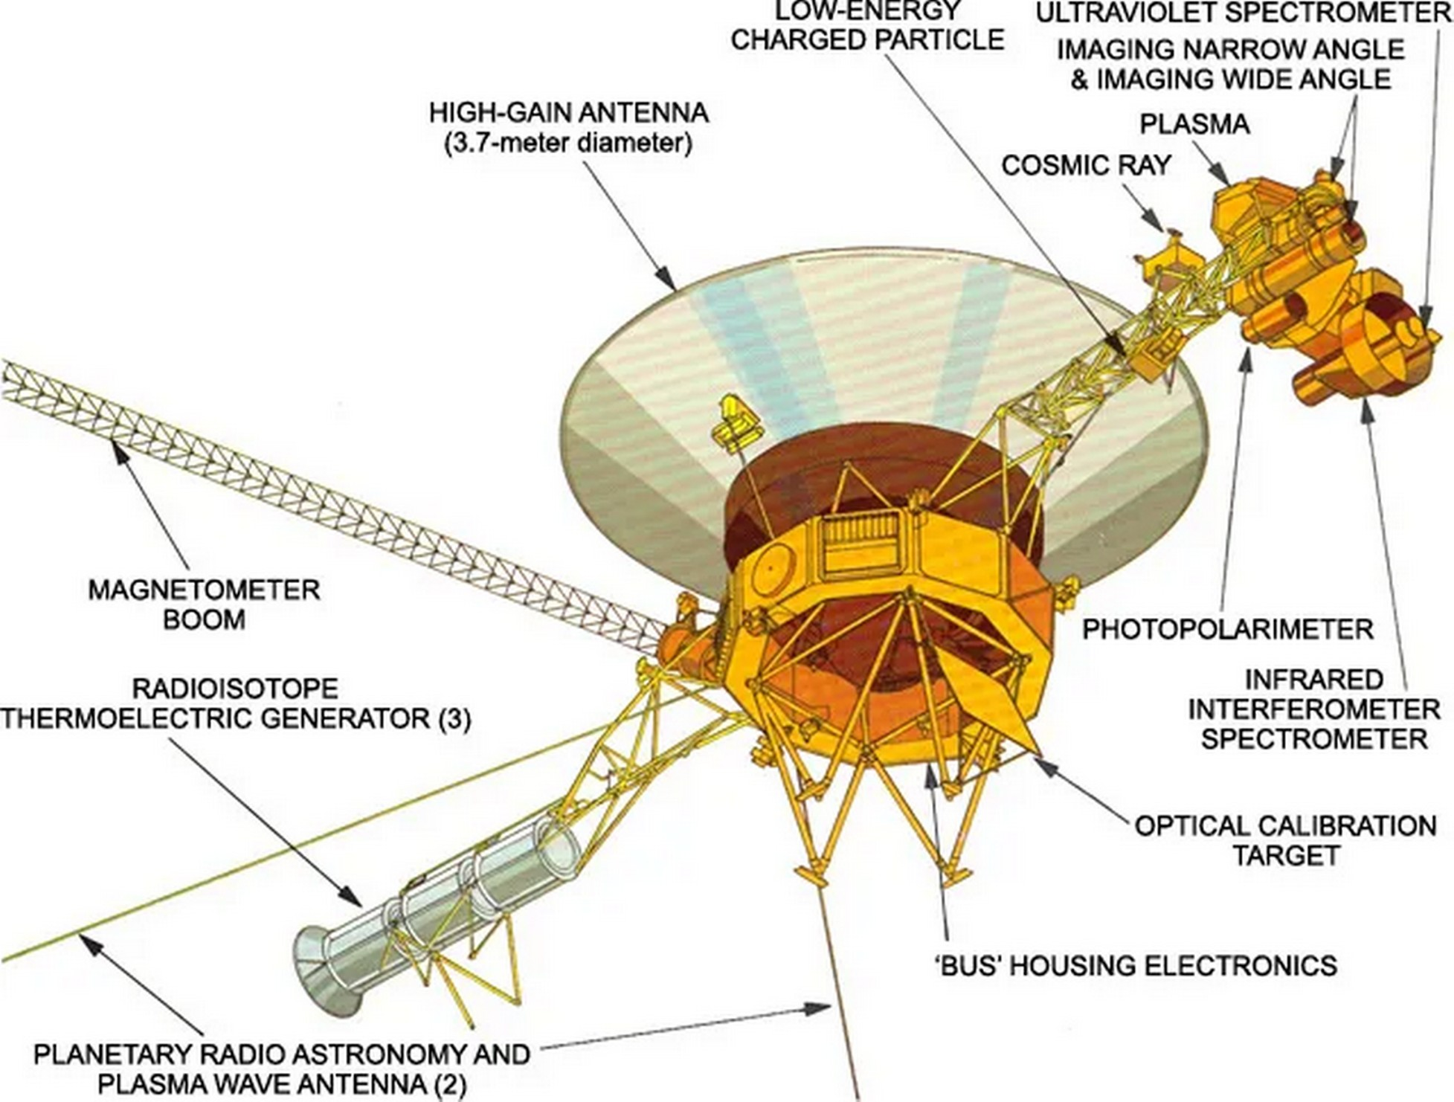
On 17 April 2026, mission engineers at NASA’s Jet Propulsion Laboratory in California sent commands to switch off the Low-energy Charged Particles experiment aboard Voyager 1. The instrument had been operating, almost without interruption, since the spacecraft left Cape Canaveral in September 1977.
The shutdown was not a fault. It was the latest in a careful sequence of sacrifices. The engineers who built it in the 1970s never expected we’d still be listening half a century later.”
Voyager 1’s three radioisotope thermoelectric generators lose about four watts of electrical output each year as the plutonium-238 inside them decays. After nearly forty-nine years, there is not much margin left. According to the announcement from JPL, switching off the LECP buys the mission roughly another year of operating headroom.
The reach of the signal is not a function of brute output. It is a function of a 3.7-metre Cassegrain antenna pointed precisely at Earth, a 70-metre receiving dish on the ground, and the unforgiving mathematics of error-corrected coding pulled out of noise.

https://spacedaily.com/voyager-1-is-still-transmitting-from-beyond-the-heliosphere-on-22-watts-less-power-than-the-bulb-in-your-hallway-and-the-engineers-who-built-it-in-the-1970s-never-expected-wed-st/
MUUG 5th Annual BBQ
Except where otherwise noted, all textual content is licensed under a Creative Commons Attribution-ShareAlike 4.0 International License.

https://creativecommons.org/licenses/by-sa/4.0/


Come one, come all, to the MUUG summer BBQ
Spouses, significant others, and children are also welcome to attend.
Date: July 14th, 2026
Time: 6:30 pm
Location: BBQ Site #5, Assiniboine Park
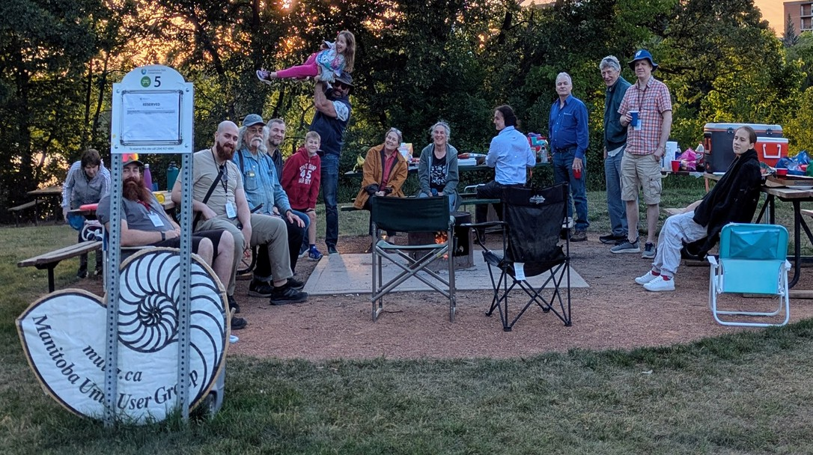
For the 5rd year in a row MUUG is hosting another BBQ event at the exact same location as the last 3 years: Assiniboine Park BBQ site #5.

Burgers, hot dogs, and pop will be provided by MUUG. Feel free to bring your own food to share with others and your own beverages if you like.

Please RSVP via email to: bbq@muug.ca before July 7th so we know how much food we need to buy and bring.
A big thanks to Les.net for providing MUUG with free hosting and all that bandwidth! Les.net (1996) Inc. is a local provider of VoIP, Internet and Data Centre services. Contact sales@les.net by email, or +1 (204) 944-0009 by phone.
MUUG would like to thank Michael W. Lucas for donating one of his ebooks every month as a door prize. You can view and purchase his tech books here:

https://www.tiltedwindmillpress.com/product-category/tech/
Thanks to Linux Mag for providing MUUG a half price magazine subscription for our door prizes.
Linux Magazine is your guide to the world of Linux and open source. Each monthly issue includes advanced technical information you won’t find anywhere else including tutorials, in-depth articles on trending topics, troubleshooting and optimization tips, and more! Subscribe to their free newsletters and get news and articles in your inbox.

https://www.linux-magazine.com/

MUUG Book Buyback
MUUG will be running a trial in which we “buy back” prior door prize dead-tree books. If you have one of these books, and are done reading it or are no longer interested in it, and it’s in “very good” or better condition, you can bring it to a meeting to “trade in”. We will then give you a one year membership (or extension) for free (a $20 value)! We will then turn around and use your book as a future door prize. It’s a win-win-win!
Note, your copy of a book does not have to have originally come from MUUG: you could have obtained it from anywhere. All that matters is it is one of the titles listed below.
These conditions apply: 1) The book must be one of the titles listed below. 2) One book per member account. 3) Books must be in very good condition or better, as judged by a MUUG board member, whose decisions are final. 4) Only open to the first ten applicants.
If the program is deemed a success we will look to expand it in the future, with possibly more titles or more books allowed per person.
The idea is to expand our available physical door prize options, increase outreach and interest in the club, increase membership, provide more value/service to our members, and reduce costs. It used to be possible to score good dead tree books for under $20 all-in, but that is becoming increasingly difficult given the recent inflationary environment.
Eligible book titles:
97 Things Every Cloud Engineer Should Know: Collective Wisdom from the Experts, by Emily Freeman
97 Things Every Programmer Should Know: Collective Wisdom from the Experts, by Kevlin Henney
Beautiful Code: Leading Programmers Explain How They Think, by Andy Oram
CSS Refactoring: Architect Your Stylesheets for Success, by Steve Lindstrom
Classic Shell Scripting: Hidden Commands that Unlock the Power of Unix, by Arnold Robbins
Cooking for Geeks: Real Science, Great Cooks, and Good Food, by Jeff Potter
Electronics All-in-One For Dummies, by Doug Lowe
Good Math: A Geek’s Guide to the Beauty of Numbers, Logic and Computation, by Mark Chu-Carroll
High Performance Images: Shrink, Load, and Deliver Images for Speed, by Colin Bendell
Make Fun!: Create Your Own Toys, Games, and Amusements, by Bob Knetzger
Managing Projects with GNU Make: The Power of GNU Make for Building Anything, by Robert Mecklenburg
Mastering Regular Expressions: Understand Your Data and Be More Productive, by Jeffrey E. F. Friedl
Masterminds of Programming: Conversations with the Creators of Major Programming Languages, by Federico Biancuzzi
On Web Typography, by Maria Jason Santa
SSH, The Secure Shell: The Definitive Guide, by Daniel J. Barrett
The Geek Atlas: 128 Places Where Science and Technology Come Alive, by John Graham-Cumming
The Hardware Hacker: Adventures in Making and Breaking Hardware, by Andrew Bunnie Huang
Think Bayes: Bayesian Statistics in Python, by Allen Downey
Understanding Compression: Data Compression for Modern Developers, by Colt McAnlis
Understanding Computation: From Simple Machines to Impossible Programs, by Tom Stuart
Unicode Explained: Internationalize Documents, Programs, and Web Sites, by Jukka K. Korpela
Version Control with Git: Powerful tools and techniques for collaborative software development, by Jon Loeliger,
Working with Static Sites: Bringing the Power of Simplicity to Modern Sites, by Raymond Camden
bash Cookbook: Solutions and Examples for bash Users, by Carl Albing

